|  |
| --- |
| U Got Died |
| U Got Died Presents |
| **[Balloon Man Assignment 4** |
| Version #1.0  All work Copyright © 2013 by U Got Died Games.  All rights reserved. |
| **Jonathan Hodder** |
|  |

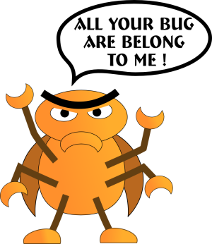**Insert a Company Logo here**

|  |
| --- |
| July 11th 2013 |

**Table of Contents**

1. **Game Overview**
2. **Game Play Mechanics**
3. **Controls**
4. **Interface Sketch**
5. **Menu and Screen Descriptions**
6. **Characters**
7. **Enemies**
8. **Items**
9. **Scoring**
10. **Sound Index**
11. **Art / Multimedia Index**

**Version History**

Version 0.1 - Code from Lesson 7.

Version 0.2 - Added the Balloon Man Class.

Version 0.25 - Added the Coin Class - Also adjusted image sizes.

Version 0.3 - Added the Balloon Class - Adjusted image sizes again.

Version 0.35 - Added the Flying Bird Class.

Version 0.4 - Removed the original code not looked at yet. Added collision logic to my code with sound effects. The sound effects are from lesson 7. Will add original sounds to my code later on.

Version 0.5 - Added screen scrolling for the sky background and also added 5 birds to the game instead of just one bird.

Version 0.6 - Added a scoreboard to the game. When colliding with a balloon you gain one life. When colliding with a coin you gain 50 points. When colliding with a flying bird you lose one life. If you run out of lives the game resets.

Version 0.7 - Added an intro to the game and when you lose the intro loads up with your last score - Need to work on making it so that when you lose you can actually quit out with escape.

Version 0.8 - Have the game over screen working also allow you to quit out when you select escape on the game over screen or intro screen.

Version 0.9 - Images alpha corrected - Added clouds to provide extra challenge and to have the background seem to move. Sound and music added to game.

#Version 1.0 - Added boss enemy with a music change. Modified images - changed cloud image and added color version for common enemies.

**Game Overview**

You are the balloon man. Fly around the sky collecting coins to increase you’re score. Also keep an eye out for balloons as they will give you an extra balloon. Watch out though birds fly through the sky and colliding with them will cause you to lose a balloon. If you run out of balloons the game is over.

**Game Play Mechanics**

*The point of the game is to move your balloon man around collections coins to increase your score and collecting balloons to get more lives. Hitting any of the birds will cause you to lose a life. If you run out of lives you lose. Clouds will hide possible rewards and enemies within them.*

**Controls**

*The balloon man is controlled by your mouse. Where your mouse goes the balloon man will follow.*

**Interface Sketch**

*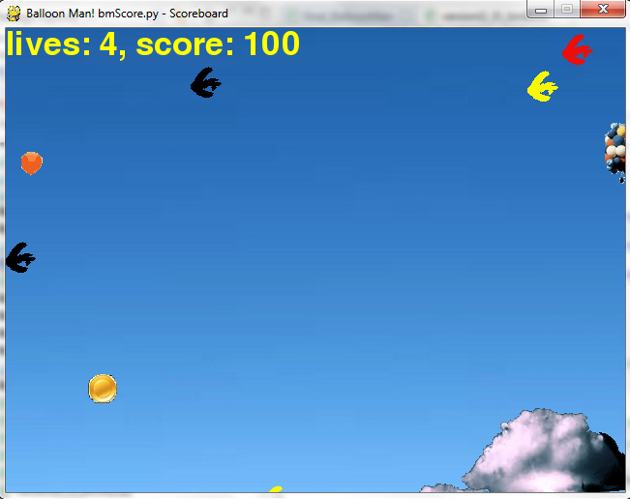*

**Menu and Screen Descriptions**

**Intro Screen – The very first screen for balloon man provides instructions on how to play the game. Click the mouse button to start the game screen or ‘esc’ to exit the game.**

**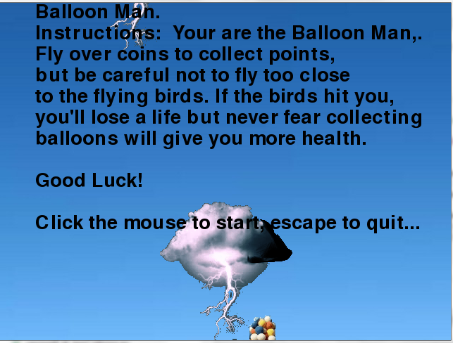**

**Game Screen – The screen where the player plays. The game screen changes to the gameover screen when the player runs out of lives.**

**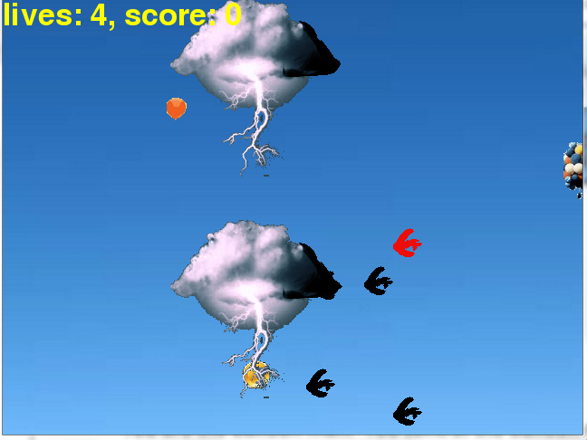**

**GameOver Screen – Game over screen that shows the final score for the player. Clicking the mouse brings you back to the intro screen and ‘esc’ to quit the game**

**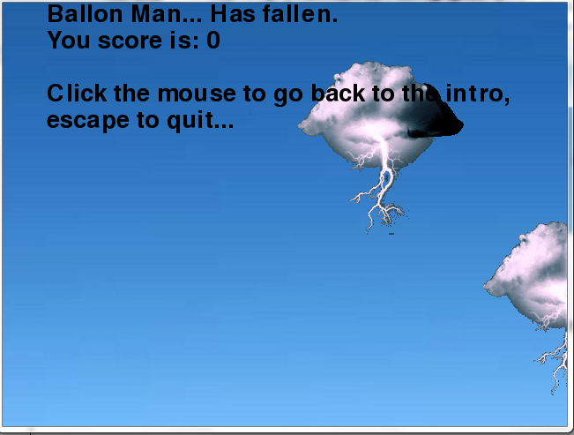**

**Characters**

*You are the balloon man. You control the balloon man by moving your mouse in any direction.*

**Enemies**

*Flying Birds – The main enemies of the game. They come in three variations black raven, red cardinal, yellow canary. Moves from the right of the screen to left.*

*Boss Bird – A giant boss bird watch out he is much faster and much larger. Moves from the right of the screen to the left.*

*Clouds – Clouds aren’t trying to hurt you but they obscure items, enemies and yourself. Move from the right of the screen to the left.*

**Items**

*Balloon – Collecting balloons add more lives for the balloon man. Balloons head from the bottom of the screen to the top of the screen.*

*Coins – Collecting coins add 50 points to your score. Be careful though when you get a certain amount of points the boss will appear*

**Scoring**

**For every coin you collect in the game you get 50 points for your score each time.**

**Sound Index**

*All sound is stored in Assignment\_4\_BalloonMan*

*balloonBlow.wav – Sound played when the balloon man collects a balloon.*

*balloonPop.wav – Sound played when the balloon man hits an enemy*

*bossSong.wav – Music played when the boss is up*

*coinSound.wav – Sound played when the balloon man hits a coin (Taken from the Mario coin sound files)*

*MGS3 Theme.wav – Music played when the boss is not up and during the intro and game over screens.*

**Art / Multimedia Index**

|  |
| --- |
| balloon.gifballoon.gif |
| balloon_man.gifballoon\_man.gif |
| cloud.gifcloud.gif |
| coin.gif coin.gif |
| flying_bird.gifflying_bird_red.gifflying_bird_yellow.gifflying\_bird(Black Raven), flying\_bird\_red(Red Cardinal), flying\_bird\_yellow (Yellow Canary). |
| flying_bird_boss.gifflying\_bird\_boss.gif |
| sky_background.gif sky\_background.gif |